

|  |
| --- |
| CoW User’s Manual |
| Cherry Point Refinery |
| Version 2.4 |

Table 1: Document Version

|  |  |  |
| --- | --- | --- |
| Date | Document Version | Description/Comments |
| May 4, 2011 | Version 1.0 | First release of manual |
| November 17, 2011 | Version 2.0 | Re-work of manual & update of changes |
| January 4, 2012 | Version 2.1 | Corrections and updates (low risk permits) |
| February 16, 2012 | Version 2.2 | Updated to reflect latest changes to software |
| March 6, 2012 | Version 2.2.1 | Updated to reflect latest changes to software |
| September 19, 2012 | Version 2.3 | TRCT Templates added, changes to low risk PTW, misc. small updates |
| October 22, 2012 | Version 2.4 | Added section on managing TRCTs, and updated Templates/Routines |

Table of Contents

1 Introduction 7

1.1 What is the CoW Database? 7

1.2 System Integration 7

1.3 Requirements 7

1.4 Nomenclature 7

1.5 User Roles 8

2 JTPC and WCC Creation 9

2.1 Maintenance Work 9

2.2 Project and TAR Work 9

3 Logging into the CoW Database 10

4 Printing Setup for the CoW Database 11

5 Planning 12

5.1 Assigning Activities to a WCC 12

5.1.1 Assigning a TRCT Number 13

5.1.2 Automatically Assigning Activities 13

5.1.3 Manually Assigning Activities 14

5.1.4 Unassigning Activities 14

5.2 Assigning a WCC to a JTPC 14

5.2.1 Automatically Assigning a WCC 15

5.2.2 Manually Assigning a WCC 16

6 Working with JTPCs 17

6.1 Finding a JTPC 17

6.1.1 Quick Search 17

6.1.2 Backlog Filters 17

6.1.3 Link from a WCC 17

6.2 Viewing and Editing a JTPC 17

6.2.1 Section A of the JTPC 17

6.2.2 WCC Section of the JTPC 18

6.2.3 Section B of the JTPC 19

7 Working with WCCs 20

7.1 Finding a WCC 20

7.1.1 Quick Search 20

7.1.2 Backlog Filters 20

7.2 Importing Templates and Routines 21

7.2.1 Importing a Template or Routine Automatically 21

7.2.2 Importing a Template or Routine Manually 21

7.3 Fields of Note 22

7.4 Supplemental Certificates 25

7.5 Attaching Documents to a WCC 26

7.5.1 Uploading a File 27

7.5.2 Linking a File 27

7.6 Adding and Reminding Approvers 27

7.6.1 Adding an Approver 28

7.6.2 Reminding an Approver 28

7.7 Approving a WCC 29

7.8 Printing a WCC 29

7.8.1 Printing a WCC Only 29

7.8.2 Printing an Entire Job Packet 29

7.9 Permits 30

7.10 Saving a WCC 30

7.11 Using the Spell Check Feature 30

7.12 Emailing a WCC 31

7.13 Deleting a WCC 32

7.14 Viewing the WCC History 32

8 Working with Permits 33

8.1 Permit Types 33

8.1.1 Low-Risk Permits 33

8.1.2 Standard Permits 35

8.2 Viewing Permits 36

8.2.1 View All Permits in the CoW Database 36

8.2.2 View All Permits for a JTPC 36

8.2.3 View Permits for a WCC 37

8.3 Creating a Permit 37

8.3.1 Creating a Permit on a WCC 37

8.3.2 Creating a Permit from the View Permits screen 37

8.4 Printing Permits 37

8.5 Duplicating a Permit 38

8.6 Adding a WCC to a Permit 38

8.7 Deleting Permits 39

9 My Profile Menu 40

9.1 Contact Info 40

9.2 Preferences 40

9.2.1 Preferences 41

9.2.2 Automatic Filters 42

9.2.3 Backlog Settings 42

9.2.4 Backfill Settings 42

9.2.5 Email Settings 42

9.3 Change Password 42

10 Working with Data Grids 44

10.1 Sorting Data using the Data Grids 44

10.2 Filtering Data Grid Results 44

10.3 Navigating Multiple Pages 44

10.4 Special Data Grids 44

10.4.1 Re-Ordering Columns 44

10.4.2 Displaying or Hiding Columns 45

10.4.3 Changing Column Widths 45

10.4.4 Grouping by Columns 45

10.4.5 Quick Sort Options 45

10.4.6 Saving Your Special Data Grid Settings 46

11 Additional Functionality for Specific Roles 47

12 Control of Work Authority and System Administrators 48

12.1 Managing Templates 48

12.1.1 Working with Base TRCT Templates 48

12.1.2 Re-Approving Routine Templates 49

12.2 Managing TRCTs 49

12.3 Setting TAR Mode 50

12.4 Managing Badges 51

12.4.1 Adding a New Badge 51

12.4.2 Editing an Existing Badge 51

12.4.3 Importing the Current Badge File 51

12.5 Managing Users 51

12.5.1 Editing User Information 51

12.5.2 Adding a New User 52

12.6 Managing Companies 52

12.6.1 Editing Company Information 52

12.6.2 Adding a New Company 53

12.7 Managing Import Files 53

12.7.1 Viewing the Status of a File 53

12.7.2 Viewing the Contents of a File 53

12.7.3 Re-Importing Files into CoW 54

12.7.4 Deleting Import Files 54

12.7.5 Archiving Files 54

12.8 Deleting JTPCs 54

# Introduction

This user’s manual is designed as a learning tool and technical reference for use with the Control of Work (CoW) Database.

## What is the CoW Database?

The CoW Database is a web application designed to simplify and standardize the Control of Work process at the BP Cherry Point Refinery. The Cow Database outputs Work Control Certificates (WCCs), Job Task Planning Certificates (JTPCs), and Permits to Work (PTWs). The CoW Database stores planning documents with their associated WCC. It is tightly integrated with the Maintenance Tracking System (MTS) and also integrates with Maximo and Primavera (P6).

## System Integration

The CoW Database first receives jobs and work orders from Primavera and Maximo. The CoW Database also ties in with the Maintenance Tracking System (MTS) to provide quick and easy electronic permitting.

## Requirements

The CoW Database requires Internet Explorer 8. Internet Explorer 8 for Windows XP can be downloaded from <http://www.microsoft.com/download/en/details.aspx?id=43>.

## Nomenclature

|  |  |
| --- | --- |
| Abbreviation | Full-Form Equivalent |
| AA | Area Authority |
| CoW | Control of Work |
| ICC | Isolation Control Certificate |
| JTPC | Job Task Planning Certificate |
| MTS | Maintenance Tracking System |
| POW | Point of Work |
| PTW | Permit to Work |
| TAR | Turn-Around |
| TRCT | Task Risk Category Table |
| WCC | Work Control Certificate |

## User Roles

Every user in the CoW Database has one or more roles. The roles determine what they are able to do in the system. For role-specific functionality, see Section 11 Additional Functionality for Specific Roles on page 47 of this user’s manual.

|  |  |
| --- | --- |
| Role | Abbreviation |
| Affected Area Authority | AAA |
| Area Authority | AA |
| Authorized Engineer | AE |
| Badge Manager | BG |
| CoW Authority | CA |
| Electrical Authority | EA |
| HSSE Manager | HM |
| Inspection Authority | IA |
| Lifting Authority | LA |
| Maintenance Manager | MM |
| Operations Foreman | OF |
| Operations Manager | OM |
| Planner | PL |
| Process Authority | PA |
| Process Superintendent | PS |
| Reliability Coordinator | RA |
| Scheduler | SC |
| System Administrator | SYSADMIN |
| Technical Authority | TA |
| TRTC Template | TT |
| View Only | VO |

# JTPC and WCC Creation

JTPCs and WCCs are created in the CoW Database once the information is available to import from Primavera or Maximo.

## Maintenance Work

Creating JTPCs and WCCs for Maintenance work begins with creating the Work Order in Maximo. The process is as follows:

1. Create the Work Order in Maximo
2. Assign the Job Steps
3. Add the Resource
4. Assign a TRCT to each step

Within 10 minutes of completion of the above steps, the jobs will be exported to the CoW Database.

## Project and TAR Work

Creating JTPCs and WCCs for Project and TAR work begins with creating Activities in Primavera. The process is as follows:

1. Create the Activity in Primavera
2. Assign a Resource
3. Assign a TRCT (use 0000 if the TRCT is unknown or unavailable)

Once a TRCT is assigned, the activity is ready to be exported to the CoW Database. The export will occur within a couple of hours.

# Logging into the CoW Database

To log into the CoW Database:

1. Using Internet Explorer 8, go to <https://www.bpcontrolofwork.com>.
2. Enter your NTID and Password.
3. Optionally, you can check the ‘Remember me next time’ box to have the CoW Database remember your credentials until you log out of the system.
4. Click **Log In**.

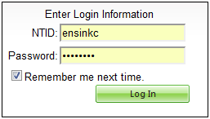

Screen Capture 1: user login screen

# Printing Setup for the CoW Database

For optimal printing of CoW Database documents, the default settings in Internet Explorer 8 need to be changed. Internet Explorer is set up by default to print in black and white, and also include unnecessary information in the Headers and Footers. To change these default settings, do the following:

1. While in Internet Explorer, press the *Alt* key on your keyboard to bring up the menu.
2. Click on **File**
3. From the drop-down menu, click **Page Setup…**
4. On the resulting screen, check the box that says ‘*Print Background Colors and Images*.’
5. In the Headers and Footers section of this same page, set all Header and Footer drop-downs to *‘-Empty-*‘.
6. Click **OK** to save the changes.

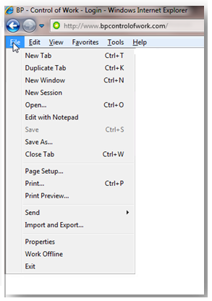

Screen Capture 2: internet explorer file menu

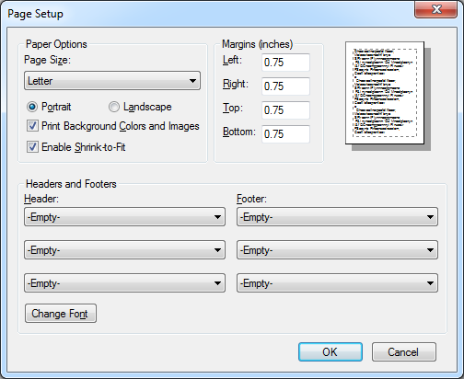

Screen Capture 3: internet explorer - page setup

# Planning

The Planning menu options in the CoW Database are available to enable you to assign activities to WCCs and to assign WCCs to JTPCs.

## Assigning Activities to a WCC

Most often, when activities are not assigned to a WCC, it is because they do not have a valid TRCT number. Activities will also not be assigned if the WCC they were attached to was deleted, or if the activity itself was manually removed from a WCC.

To assign activities to a WCC, click on **Assign Activity to WCC** on the *Planning Menu*. The resulting screen lists all unassigned activities first, followed by active WCCs below. To the right of your screen is a planning sidebar, which has ‘Activities’ and ‘My Recent WCCs’. If you do not see this sidebar, you can scroll to the right in Internet Explorer.

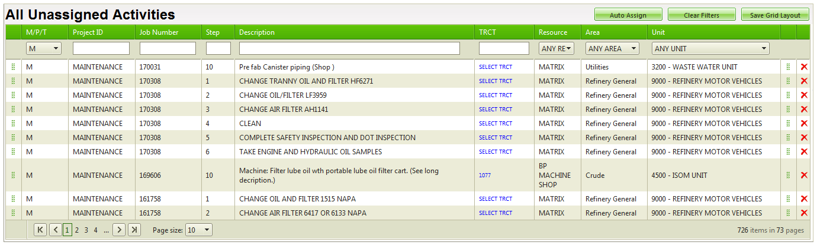

Screen Capture 4: planning - unassigned activities

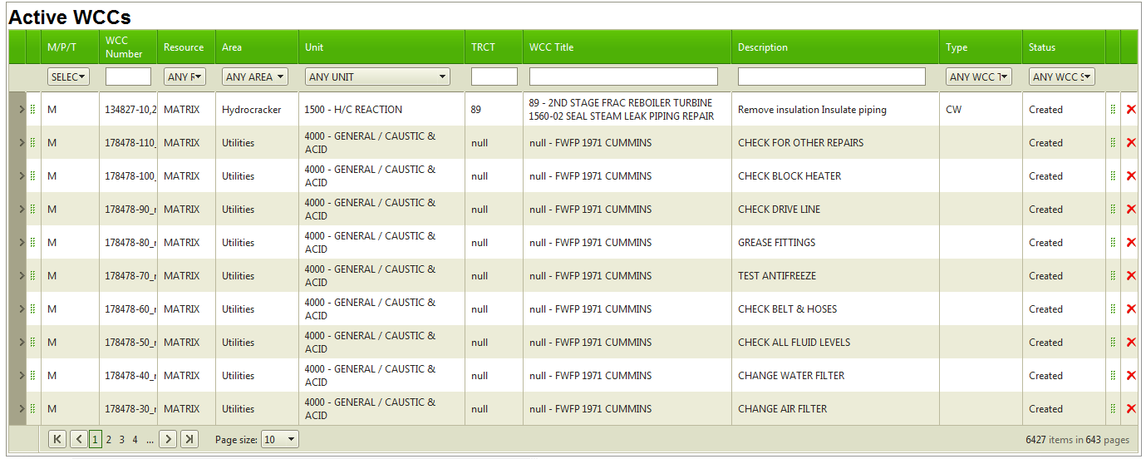

Screen Capture 5: planning - active wccs

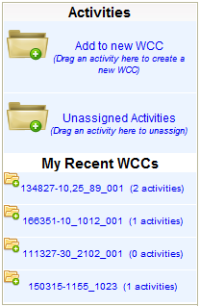

Screen Capture 6: planning sidebar

### Assigning a TRCT Number

Before activities can be assigned, they must have a valid TRCT number. Therefore, your first step in assigning activities to a WCC is to give each activity a TRCT number.

To assign a TRCT number to unassigned activities:

1. Refine the list of unassigned activities by using the ‘All Unassigned Activities’ data grid. You can enter the job number to list only activities for a particular job, or you can filter by other columns as desired. For more information on working with data grids, see Section 10 Working with Data Grids on page 44 of this user’s manual.
2. Once you have the list of activities you want to assign to WCCs, you can select a TRCT for each activity. For each activity, click **SELECT TRCT** from the TRCT column.
3. The ‘Select TRCT’ window will open up. If you know the TRCT number you wish to use, enter it in the TRCT column. Otherwise, you can refine the list of TRCT numbers by using the Job Type and Risk Level drop-downs and the data grid.
4. Once you have the TRCT Number you want to use, select it from the list, and click **Select**. A confirmation dialog box will ask you to confirm your choice. Click **OK** to continue.
5. Repeat this process for all activities on your list.

### Automatically Assigning Activities

Once you’ve added the TRCT numbers to your activities, you can have them automatically assigned to WCCs.

1. If you haven’t done so yet, filter the ‘All Unassigned Activities’ grid by the Job Number or filter of your choice to show all the activities you want to assign. The CoW Database will attempt to assign ALL activities listed here to WCCs.
2. Look to see that all activities listed here have a correct TRCT Number. If they do not have a TRCT Number assigned, they will not be assigned to a WCC.
3. Click the **Auto Assign** button.

### Manually Assigning Activities

Once you’ve added the TRCT numbers to your activities, you are able to manually assign them to WCCs.

On the far left and right ends of each row (activity), you will see a ‘grab’ icon (). To grab an activity and drag it to a WCC to assign it, click and hold down the left mouse button while your mouse pointer is on the ‘grab’ icon and release the mouse button once you’ve moved the activity to the WCC you want it assigned to. 

Screen Capture 7: planning - activities with 'grab' icons

Activities can be assigned manually in three ways:

* To add an activity to a new WCC, drag and release the activity on the Planning sidebar, in the *Activities* section in the ‘Add to new WCC’ area.
* To add an activity to one of your recent WCCs, drag and release the activity on the WCC in the ‘My Recent WCCs’ area of the Planning sidebar.
* To assign an activity to any active WCC in the CoW Database, use the data grid for the *Active WCCs* to filter your results. Drag and release the activity to the active WCC of your choice.

### Unassigning Activities

There are two ways to unassign an activity from a WCC. If you assigned the activity recently, you can remove the activity from the *Assign Activity to WCC* screen. Otherwise, activities can be removed from opening the individual WCC they are assigned to.

For activities you’ve assigned to a WCC recently, navigate to the *Assign Activity to WCC* screen. Locate the WCC in the Planning sidebar, under *My Recent WCCs*. Click the WCC to bring up a list of activities for that WCC. To remove an activity, grab it using the ‘grab’ icon, and move it to the ‘Unassigned Activities’ area of the Planning sidebar.

To remove activities from WCCs that aren’t listed under ‘My Recent WCCs,’ use the WCC Backlog to find and open the WCC. In the ‘Activity/Task List’ area of the WCC, find the activity and click the remove () icon. The activity will NOT be deleted, but instead be moved to the *All Unassigned Activities* data grid (found on the ‘Assign Activity to WCC’ screen).

## Assigning a WCC to a JTPC

When WCCs are created using the CoW Database rather than through the normal import process, they need to be assigned to a JTPC. The exception to this is Maintenance projects, which will be assigned by the system.

For Project and TAR work, you can assign a WCC to a JTPC either manually or automatically.

To assign activities to a WCC, click on **Assign WCC to JTPC** on the *Planning Menu*. The resulting screen lists all unassigned WCCs first, followed by active JTPCs below. To the right of your screen is a Planning sidebar, which has ‘WCCs’ and ‘My Recent JTPCs’. If you do not see this sidebar, you can scroll to the right in Internet Explorer.

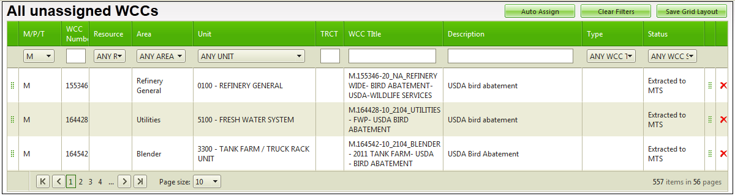

Screen Capture 8: planning - all unassigned wccs

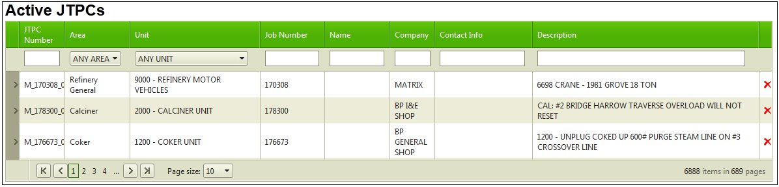

Screen Capture 9: planning - active jtpcs

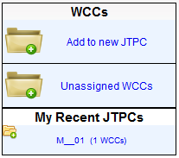

Screen Capture 10: planning sidebar

### Automatically Assigning a WCC

To have the CoW Database automatically assign WCCs to a JTPC, do the following:

1. Filter the ‘All Unassigned WCCs’ data grid to display only the WCCs you wish to have automatically assigned. For more information on working with data grids, see Section 10 Working with Data Grids on page 44 of this user’s manual.
2. Click **Auto Assign**.

### Manually Assigning a WCC

To manually assign a WCC to a JTPC, you ‘grab’ the WCC from the ‘All Unassigned WCCs’ data grid, and drop it on the JTCP you want to attach it to. On the far left and right ends of each row (WCC), you will see a ‘grab’ icon (). To grab a WCC and drag it to a JTPC to assign it, click and hold down the left mouse button while your mouse pointer is on the ‘grab’ icon and release the mouse button once you’ve moved the activity to the JTPC you want it assigned to.

WCCs can be assigned manually in three areas:

* To add a WCC to a new JTPC, drag and release the WCC on the Planning sidebar, in the *WCCS* section in the ‘Add to new JTPC’ area.
* To add a WCC to one of your recent JTPCs, drag and release the WCC on the JTPC in the ‘My Recent JTPCs’ area of the Planning sidebar.
* To assign a WCC to any active JTPC in the CoW Database, use the data grid for the *Active JTPCs* to filter your results. Drag and release the activity to the active JTPC of your choice.

# Working with JTPCs

The JTPC is an overview of all WCCs for a particular job. While viewing a JTPC, you can access all WCCs related to the current JTPC, and also see the status of all approvals for all WCCs related to the current JTPC.

## Finding a JTPC

There are three ways to locate a JTPC in the CoW database: you can use the *Quick Search* feature, you can use your backlog filters, or you can link to the JTPC from any WCC on the JTPC.

### Quick Search

Use the *Quick Search* box in the upper left of your screen to find your JTPC. You can search by Area, Unit Name, Company, AMR Number, Work Order Number, Description, WCC Number, Equipment ID, or Project ID.

From the search results, find and double click the JTPC you want to open.

### Backlog Filters

To find your JTPC using your backlog filters, view your backlog list by clicking **JTPC Backlog** from the *Approvals* section of the *Main Menu*. Use the drop-down lists and text boxes to refine the JTPC list until you see the results you want. See Section 10 Working with Data Grids on page 44 of this user’s manual for more information about working with data grids. Double click the JTPC you want to open.

### Link from a WCC

If you are on a WCC, you can link to its JTPC. Locate the JTPC Number, found at the top of the WCC, just to the left of the bar-code, and click it.

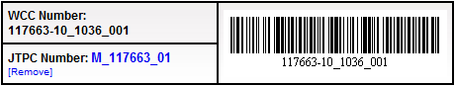

Screen Capture 11: jtpc number on a wcc

## Viewing and Editing a JTPC

Once you’ve located the JTPC you wish to work with, you can view or edit the information contained on it.

### Section A of the JTPC

In Section A of the form, missing information can be completed and pre-existing information can be verified.

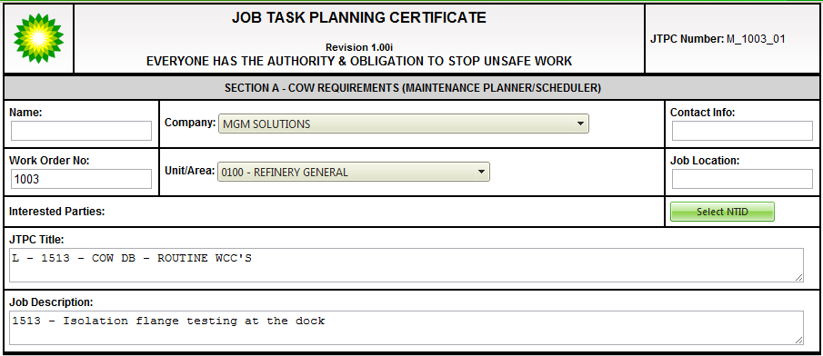

Screen Capture 12: jtpc section a

#### Interested Parties

People listed in the *Interested Parties* field will be notified when ALL WCCs for the current JTPC have been approved.

To add people to the *Interested Parties* field, click **Select NTID** and use the data grid filters to refine the list.

To remove people, click their NTID from the *Interested Parties* field.

### WCC Section of the JTPC

In this area of the JTPC, the WCCs related to the current JTPC are listed. From here, you can change the TRCT Number, select the lift type, create and modify supplemental certificates, and change the WCC status for all WCCs on the current JTPC.

**NOTE**: Changing the TRCT Number will change the WCC number for Maintenance jobs.

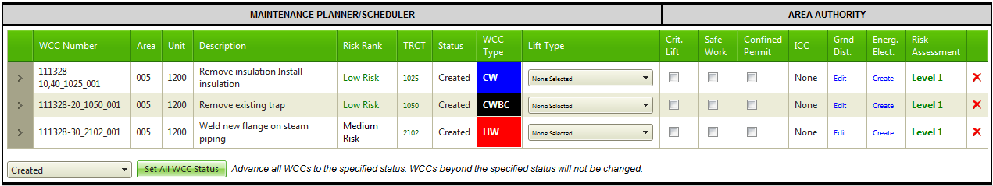

Screen Capture 13: jtpc - wcc list

#### Creating and Modifying Supplemental Certificates

To create or modify a *Ground Disturbance* or *Energized Electrical* supplemental certificate, locate the WCC in the WCC list for the current JTPC. In the *Ground Disturbance* or *Energized Electrical* columns, click *Edit* or *Create*. Fill in or modify the certificate information. On the *Certificate* *Menu*, click **Save Certificate**.

To go back to the JTPC, click **Return to JTPC** on the *Certificate Menu*.

#### Changing the WCC Status

To change the WCC status for **all** WCCs on the current JTPC, scroll down to the bottom of the WCC list on the current JTPC. Select the status you want, and then click **Set All WCC Status**. Please note that *all* WCCs for this JTPC will have their status changed, *unless* their status is already beyond that of the newly specified status.

### Section B of the JTPC

Section B of the JTPC shows a compiled list of all approvers, on all WCCs, for the current JTPC. From here, you can see who still needs to approve WCCs for this JTPC, as well as who has already approved WCCs.

Approvers can use this area to approve all WCCs that have them listed as the approver for this JTPC. Click **Approve All WCCs** to do this.

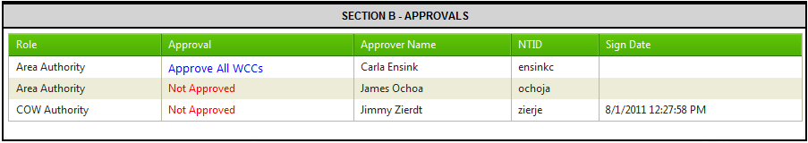

Screen Capture 14: jtpc - section b

# Working with WCCs

In the CoW Database, WCCs are populated with information. Some of that information is generated automatically, and some needs to be filled in. Relevant documents can be attached to WCCs. WCCs can be viewed, printed, and saved. This section covers how to work with WCCs in the CoW Database.

## Finding a WCC

There are two ways to locate a WCC in the CoW database: you can use the *Quick Search* feature, or you can set up your backlog filters to select a WCC from a refined list of WCCs.

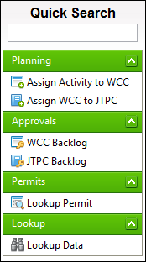

Screen Capture 15: main menu

### Quick Search

To find a WCC using Quick Search, enter your search data into the *Quick Search* field (located on the upper left of your screen) and press ‘Enter’ on your keyboard. You can search by Area, Unit Name, Company, AMR Number, Work Order Number, Description, WCC Number, Equipment ID, TRCT Number, or Project ID.

From the search results, find and double click the WCC you want.

### Backlog Filters

To find your WCCs using your backlog filters, view your backlog list by clicking **WCC Backlog** from the *Approvals* section of the *Main Menu*. Use the drop-down lists and text boxes to refine the WCC list until you have the results you want. See Section 10 Working with Data Grids on page 44 of this user’s manual for more information about setting up data grids. Double click the WCC you want to open.



Screen Capture 16: wcc backlog

## Importing Templates and Routines

There are three different import options which can speed up data entry for a WCC: WCC Templates, Base TRCT Templates, and Routines.

WCC Templates can be used when you have a pre-existing WCC that is similar to the current WCC. Any previously created WCC can be used as a template. The information is copied to the current WCC, overwriting any data that has already been added. Approvals do not copy over, and any of the data can be changed as needed.

Base TRCT Templates can be used when the TRCT number matches your current WCC’s TRCT number, and you are performing a similar task. Approvals do not copy over, and some text will be read only. TRCT Templates must be created, approved, and enabled by a Control of Work Authority to be available for selection.

Routines are for specific jobs that are done often and/or have been determined to be low-risk. The data copied from using a routine cannot be changed, and the approval information is copied to the new WCC.

### Importing a Template or Routine Automatically

If one or more applicable templates are found when first opening a WCC, a popup dialog will appear, asking you if you want to select one of them. Click **OK** to see the list. Find the template you wish to use, highlight it, and click **Select**.

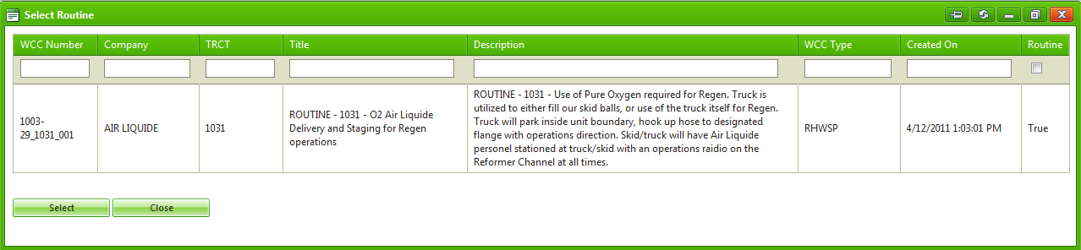

Screen Capture 17: wcc - select routine

### Importing a Template or Routine Manually

Templates and routines can also be imported manually after a WCC has been opened. Please note that importing a template will overwrite any changes that have been made to the WCC.

To manually select a template or routine, click **Templates/Routines** on the WCC Menu. Select the appropriate tab for the type of template you wish to use. Use the grid filters to locate and highlight the template to import, and click **Select**.

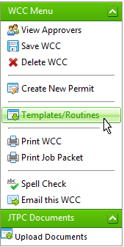

Screen Capture 18: wcc menu - templates/routines

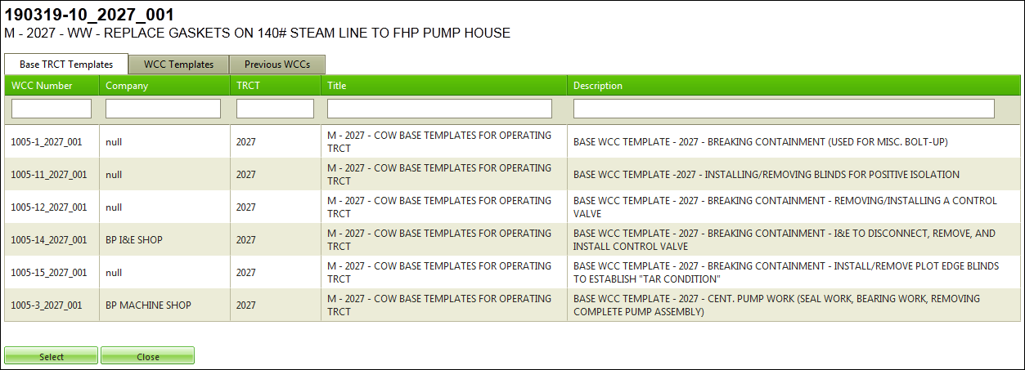

Screen Capture19: template tabs

## Fields of Note

Fields that have special functions or require additional explanations are noted here.

WCC Status:

The WCC Status indicates the stage of the WCC in the CoW process. Each status has a specific meaning and purpose, which is discussed below.

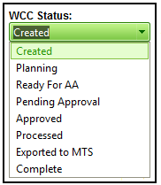

Screen Capture 20: wcc – wcc status drop-down

The statuses are as follows:

Created

* This status is set automatically.
* The WCC is unlocked in this status.
* The WCC status is automatically set to *Created* when the WCC is first created and has not yet been modified.

Planning

* This status is set automatically, and can also be changed manually.
* The WCC is unlocked while the status is set to *Planning*.
* The first time a user opens a WCC, the status will automatically change from *Created* to *Planning*. The WCC in most cases should remain in this status until it is ready for approval.

Ready for AA

* This status must be set manually.
* With this status, the WCC is unlocked.
* This status indicates that the WCC is ready for review by an AA. This status also helps an AA locate the WCC (set Status to ‘Ready for AA’ on the WCC Backlog).
* At this stage, AAs can modify the WCC and add additional approvers.

Pending Approval

* This status must be set manually.
* With this status, the WCC is locked.
* The AA should set the status to *Pending* *Approval* once they have made any necessary modifications to the form and have added the list of approvers.
* **NOTE:** Once this status has been set, the WCC is locked and no changes can be made unless the status is changed back to *Planning*.

Approved

* This status is set automatically. It should NOT be set manually.
* With this status, the WCC is locked.
* Once the last approver has approved the WCC, the status will automatically be set to *Approved*. An email will be sent to all persons on the *Interested* *Parties* list, indicating that the WCC has been approved. Additionally, the CoW database will export the WCC information back into Primavera.

Processed

* This status is set automatically. It should NOT be set manually.
* With this status, the WCC is locked.
* The WCC Status is set to *Processed* after the CoW database has successfully exported the WCC information back into Primavera.

Exported to MTS

* This status is set automatically. It should NOT be set manually.
* This status is set once the WCC has been exported to the Maintenance Tracking System (MTS).

Complete

* This status is set automatically and can also be set manually.
* With this status, the WCC is locked.
* This status indicates that the job has been worked to completion.

TRCT Number:

The Task Risk Category Table Number is coded to generally describe the work to be done and the risk level associated with that work. The TRCT Number is used to determine the WCC type.

To change the TRCT for a WCC, find the *TRCT Number* in the *Work Control Certificate General Information* section of the WCC and click **Change**.

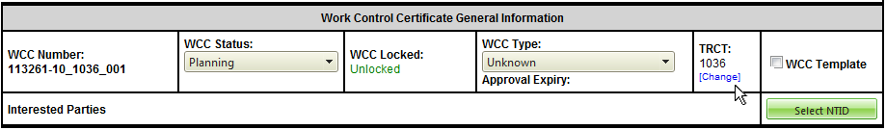

Screen Capture 21: wcc - trct number

For maintenance activities, changing the TRCT Number will also cause the WCC number to change.

**NOTE**: Changing the TRCT Number will change it for all activities on the WCC.

WCC Type:

The WCC type is automatically set based on the TRCT Number, but it can be changed manually. Use the WCC Type drop-down menu to select from the list.

Changing the WCC Type will alter the form in Section B (near the bottom of the form), and new information may be required as a result.

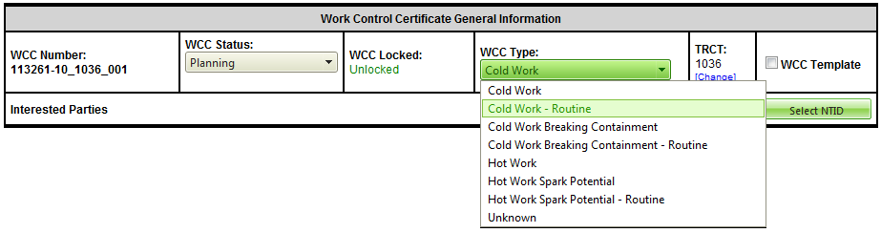

Screen Capture 22: wcc - wcc type

ICC Plan Number:

If the ICC was created in the RIPT Tool, the plan number can be entered into the ICC *Plan Number* field. Entering the plan number will allow you to open the Isolation Plan directly from the WCC or JTPC forms.

**NOTE**: For the link to work, the plan number must be entered as digits only, with no characters or spaces.



Screen Capture 23: wcc - icc plan number

Interested Parties:

Use this feature to alert individuals when a particular WCC is fully approved. Click **Select NTID** for the list of people that can be alerted.

To remove someone from this list for the current WCC, click their NTID from the *Interested* *Parties* field.

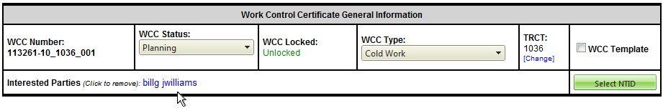

Screen Capture 24: wcc - interested parties

## Supplemental Certificates

Ground Disturbance and Energized Electrical supplemental certificates can be created and modified within the CoW database.

#### Creating a Supplemental Certificate

To add a *Ground Disturbance* or *Energized Electrical* supplemental certificate, go the *Supplemental Certificate* section of the WCC and click either *Add Ground Disturbance Certificate* or *Add Energized Electrical Certificate*. Complete the form.

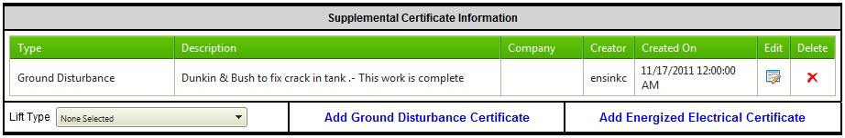

Screen Capture 25: wcc - supplemental certificates

To save the certificate, go to the *Certificate Menu* and click **Save** **Certificate**.

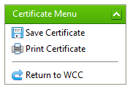

Screen Capture 26: certificate menu

Click **Return to WCC** on the *Certificate Menu* to return to the WCC.

#### Modifying a Supplemental Certificate

All created certificates are listed in the Supplemental Certificate Information section of the WCC. From there, a certificate can be edited or deleted by clicking the corresponding icon (shown below).

*Edit* Icon

*Delete* Icon

## Attaching Documents to a WCC

Documents can be attached by being uploaded or being linked. Linked files are only viewable from BP computers within the BP network. MTS stations do not have access to linked files.

Although documents can be uploaded or linked while on the WCC, the documents are attached to the JTPC and are available to all WCCs on that JTPC. Documents can also be uploaded on the JTPC with the same results.

To attach documents to the WCC, go the left side menu bar, under *JTPC Documents*, and click **Upload Documents**.

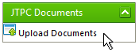

Screen Capture 27: jtpc menu - upload documents

### Uploading a File

On the *Upload File* tab, click on a field or click on **Open File**. Navigate to the file, select it, and click **Open**.

If you wish to upload more than three files, click **More Files**, then follow the process described above to upload the files.

Once all of the files you wish to upload have been selected, click **Upload** to complete the process and return to the WCC.

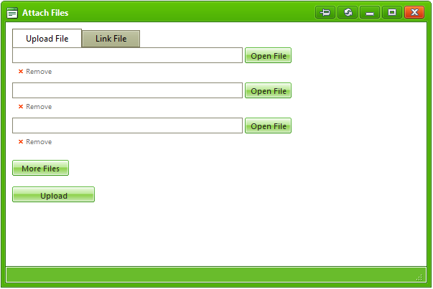

Screen Capture 28: wcc - attaching a file

### Linking a File

Use this option for linking to files within the BP network, especially living documents that are continually modified. Linking ensures the WCC will link to the most recent version of the file.

On the *Link File* tab, enter the file link. Click **Attach Link** to complete the process and return to the WCC.

## Adding and Reminding Approvers

Approvers should only be added after the WCC has been filled out and is ready for approval. Once an approver has been added, they will immediately be sent an email notification, indicating that the WCC is ready for approval.

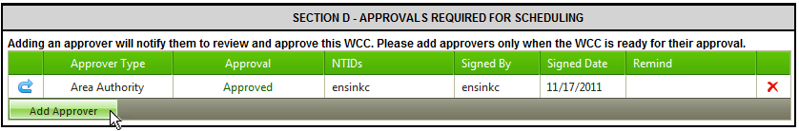

Screen Capture 29: wcc section d - approvers

### Adding an Approver

To add an approver, click **Add** **Approver** on *Section D* of the form. Select the **Approver Type** from the drop-down menu. Please note that if you are adding an *Affected Area Authority* you must select *Affected Area Authority* from the drop-down list (NOT *Area Authority*) to have them flagged correctly. If further filtering is necessary, use the data grid filters. Click **Add**. A notification email will immediately be sent out to the approver.

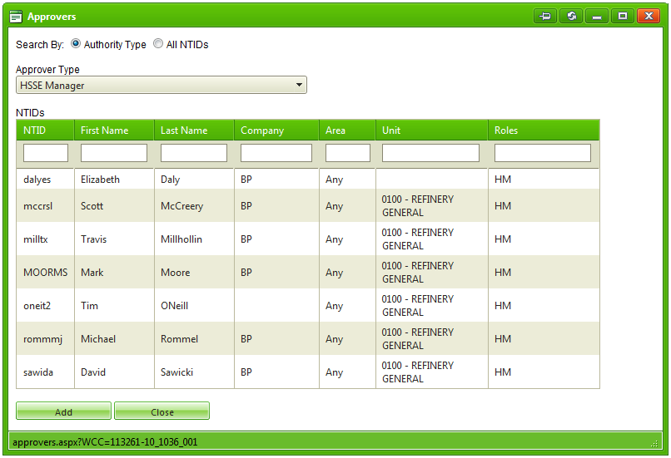

Screen Capture 30: wcc - approvers list

### Reminding an Approver

Click **Send Reminder** in *Section D* of the WCC to send a reminder email to an approver if the approval is taking too long. A copy of the email reminder will also be sent to the initiator of the reminder (you).

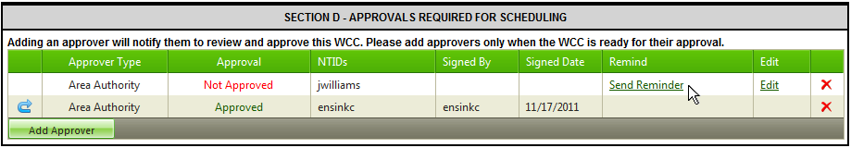

Screen Capture 31: wcc - remind approver

## Approving a WCC

To approve a WCC, open the WCC and scroll down to *Section D – Approvals*. Click **Approve Now** to approve the WCC and have the signature and date fields automatically populated.

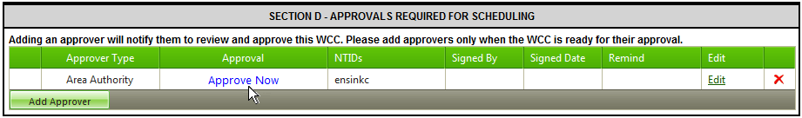

Screen Capture 32: wcc - approve now

Once all of the approvers listed on the WCC have approved it, the *WCC Status* in the *Work Control Certificate General Information* section will be changed to *Approved*. An email is then sent to all persons listed in the *Interested Parties* field.

## Printing a WCC

A WCC can by printed alone, or the entire job packet can be printed.

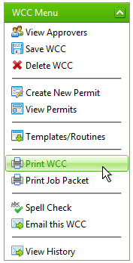

Screen Capture 33: wcc menu - print wcc

### Printing a WCC Only

On the *WCC Menu*, click **Print WCC**. A printer properties dialog box will open. Select a printer and change the printer properties as desired.

### Printing an Entire Job Packet

On the *WCC Menu*, click **Print Job Packet**. From the resulting screen, click **Print All** to print all of the documents, or use the mouse to highlight and select the documents you wish to print. When ready, click **Print Selected Documents**.

A printer properties dialog box will open. Select a printer and change the printer properties as desired.

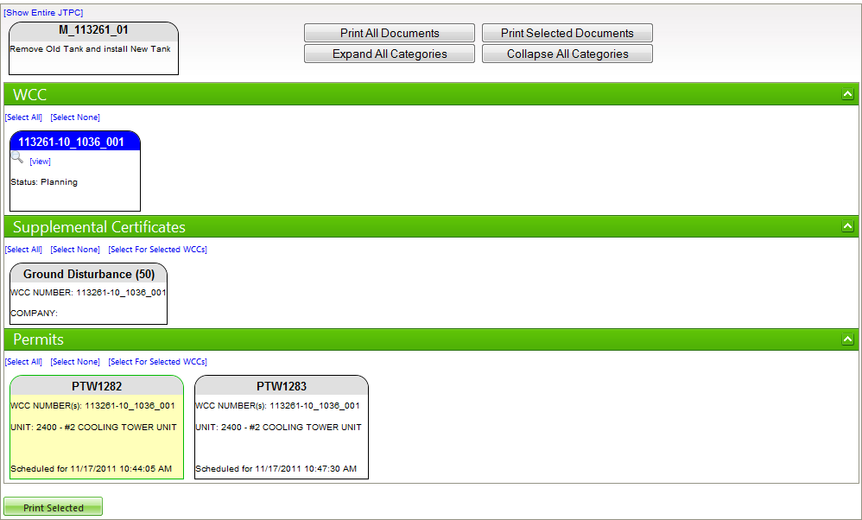

Screen Capture 34: wcc - print entire job packet

## Permits

Permits are covered in Section 8 Working with Permits on page 33 of this user’s manual.

## Saving a WCC

If auto-save is enabled in the user preferences, the WCC will save after 5 seconds of inactivity (not entering or editing data in a field). Mouse movement does not constitute activity. For details on enabling the auto-save preference, see Section 9.2.1 Preferences on page 41 of this user’s manual.

Manually saving a WCC can be done in one of two ways. On the *WCC Menu*, click **Save WCC**. A **Save** **WCC** button is also located at the bottom of the WCC. If your spell-check preference is enabled, the spell check occurs before saving.

## Using the Spell Check Feature

On the *WCC Menu*, click **Spell Check**. The spell checker will check most data fields, but excludes some, such as the *Name* field.

You can **Ignore** the spelling error, **Ignore All** instances of the same spelling error, permanently **Add Custom** word to the system dictionary so that the word is no longer shown as a spelling error, **Change** the word to one of the suggestions from the suggestion list, or **Change All** words spelled the same way throughout the WCC.

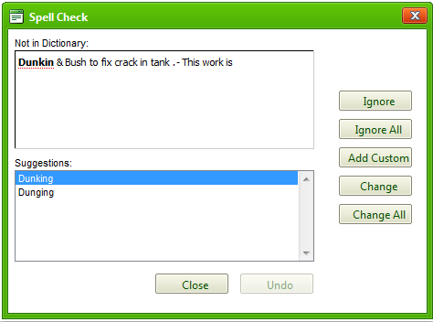

Screen Capture 35: wcc - spell check

See Section 9.2.1 Preferences on page 41 of this user’s manual for setting up the spell-check feature to automatically check for spelling upon saving the WCC.

## Emailing a WCC

On the left side menu bar, in the *WCC Menu*, click **Email this WCC**. From the drop-down menu, select the person(s) you wish to email about this WCC.

To add a note in the email being sent, use the *Add Note* field to add the additional information.

Click **Send** to send the email, or click **Close** to return to the WCC without sending the email.

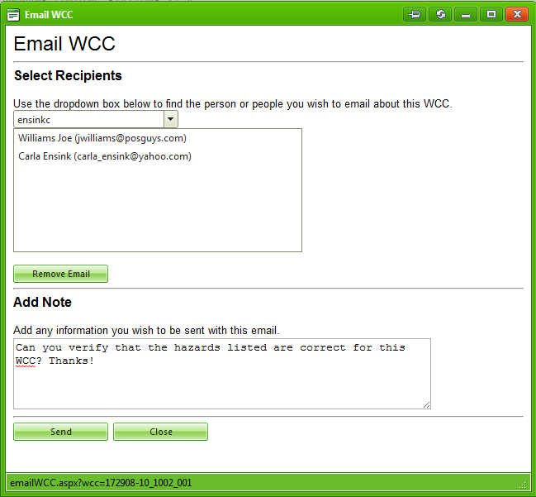

Screen Capture 36: email wcc screen with sample data filled in

## Deleting a WCC

**NOTE**: Deleting a WCC is permanent!

To delete a WCC, go to the *WCC Menu* and click **Delete WCC**. A confirmation message will ask you to confirm the deletion. Click **OK** to delete the WCC, or **Cancel** to go back to the WCC without deleting it.

## Viewing the WCC History

To view the history of changes made to the current WCC, click **View History** on the *WCC Menu*.

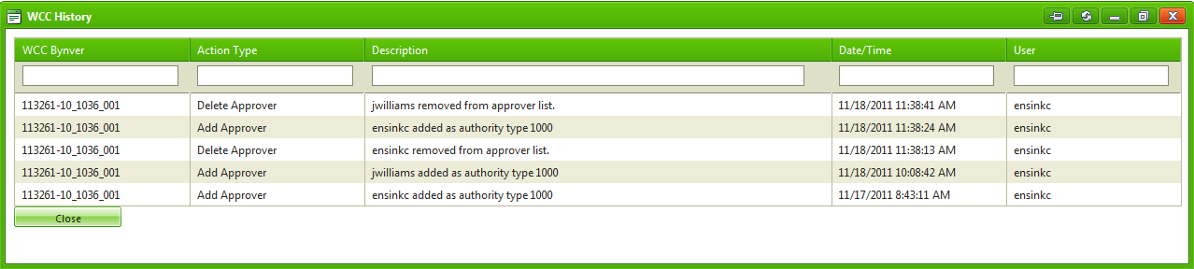

Screen Capture 37: wcc - wcc history

The *View History* records the date, time, user, and description for the following changes:

* WCC creation
* status changes
* imported templates
* added approvers
* deleted approvers
* added approvals
* removed approvals
* changes to the TRCT
* renaming of the WCC
* emailing an approver
* exports to Primavera
* WCC deletions

# Working with Permits

Permit creation within the CoW Database is optional; however, there are several advantages to creating permits this way. Permits created in the CoW Database can be created ahead of time and printed out before the job is worked. Parts of the form are automatically populated, saving time and lending consistency from permit to permit. Permit information is also easy to track after the job has been worked.

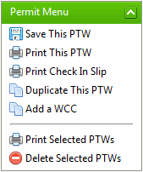

Screen Capture 38: permit menu

## Permit Types

There are two types of permits: low-risk permits and standard permits.

### Low-Risk Permits

Low-risk permits are valid for 7 days (or 14 days for TAR work). Although they are valid for multiple shifts, they still need to be re-validated and re-printed every shift. Re-validation takes place in the shelter. Low-risk permits must be approved before the work can be done, and the approval must be done by the AA for the area the job takes place in.

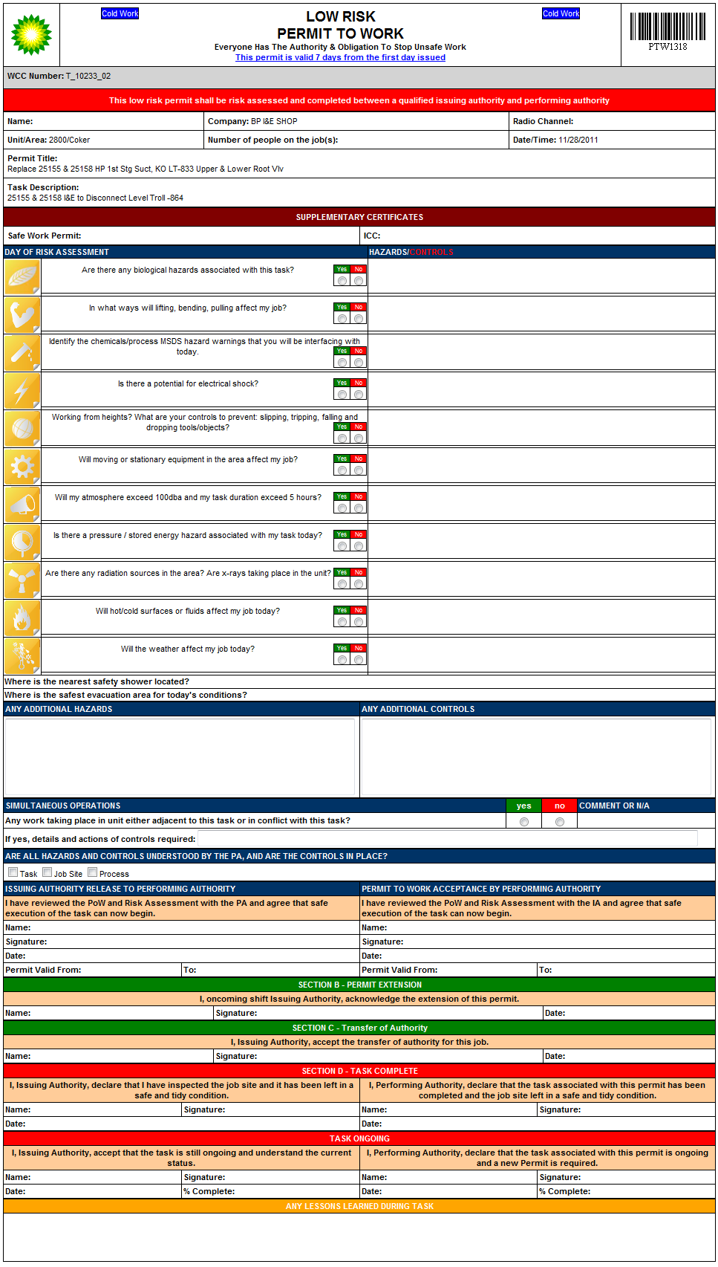

Screen Capture 39: low-risk ptw

### Standard Permits

Standard permits are used for medium and high risk jobs. They are valid for one shift.

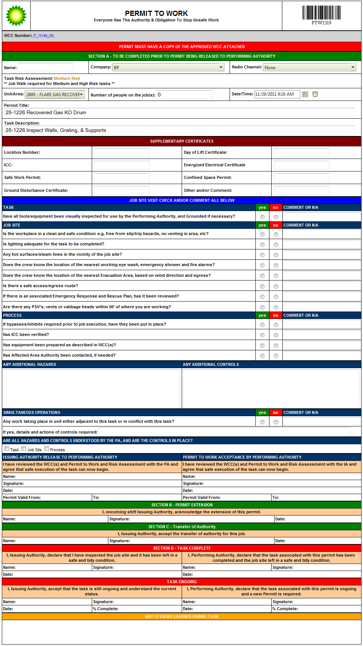

Screen Capture 40: standard ptw

## Viewing Permits

There are 3 ways to view PTWs in the system. You can view all permits in the CoW Database, view all permits related to a specific JTPC, or view permits for a specific WCC.

### View All Permits in the CoW Database

To view all PTWs in the CoW Database, click **Lookup Permit** in the *Permits* section of the *Main Menu*. Use the data grid to further refine the list as needed. For help on using the data grids see Section 10 Working with Data Grids on page 44 of this user’s manual.

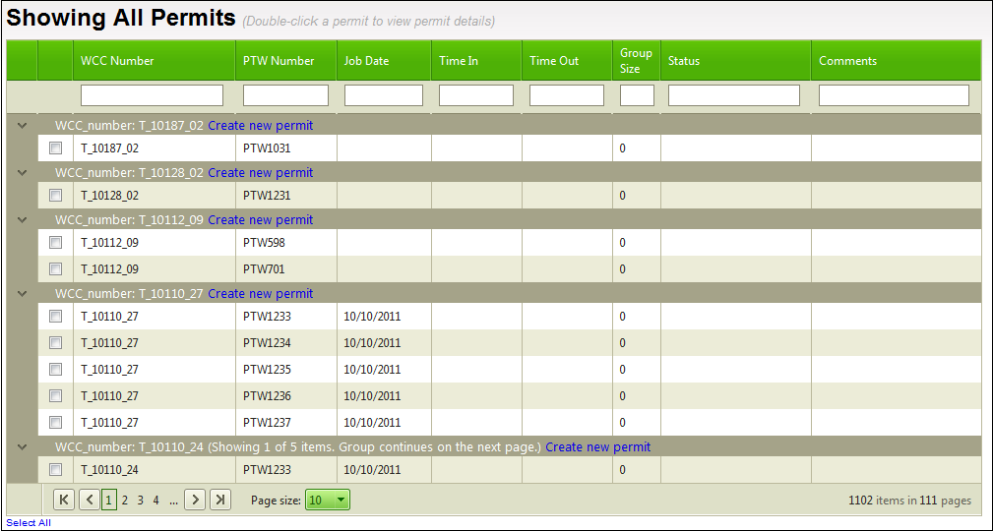

Screen Capture 41: lookup permit (view all)

### View All Permits for a JTPC

Once you have a specific JTPC on your screen, you can view all permits for that JTPC by going to the *JTPC Menu* and clicking **View Permits**.

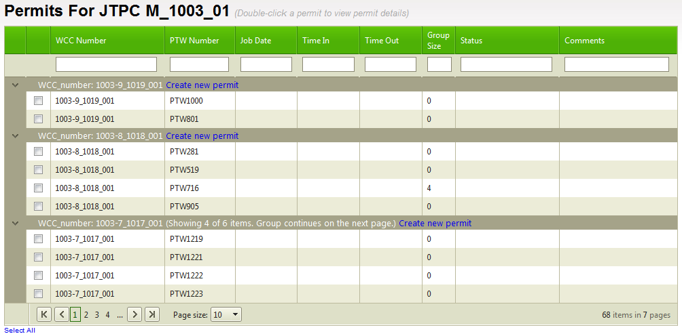

Screen Capture 42: jtpc - view all permits for a jtpc

### View Permits for a WCC

Finally, you can view permits for a specific WCC. To do so, open the WCC and on the *Permit Menu*, click **View Permits**. Note that for low-risk jobs, when you try to view the WCC you will instead be taken directly to the permit.

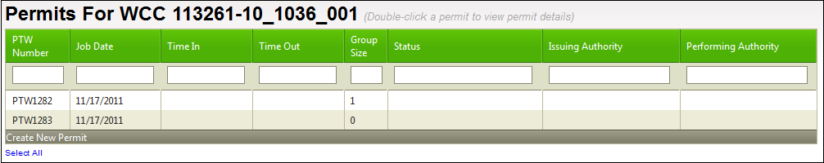

Screen Capture 43: view permits for a wcc

## Creating a Permit

A new permit can be created from a WCC, or on the *View Permits* screen. Once you’ve created a new PTW, fill in as much information as possible, and then click **Save This PTW** from the *Permit Menu*.

### Creating a Permit on a WCC

To create a PTW on a WCC, click **Create New Permit** from the *WCC Menu*. Note that low-risk permits cannot be created this way as they do not have WCCs associated with them.

### Creating a Permit from the View Permits screen

To get to the *View Permits* screen, click **Lookup Permit** on the *Permit* section of the *Main Menu*. Click the ‘*Create new permit*’ link located to the right of the WCC number you wish to create the permit for.

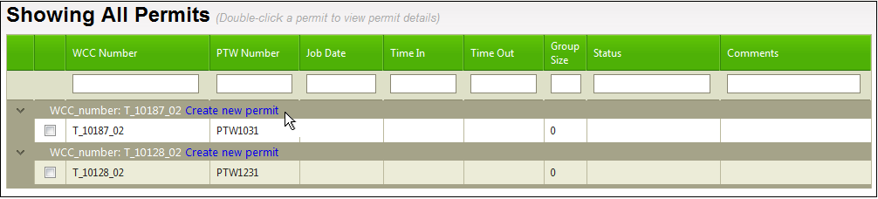

Screen Capture 44: showing all permits - create new permit

## Printing Permits

You can print a single permit or print multiple permits.

To print a single permit, have the permit open, then, click either **Print this PTW** *or* **Print Check-In Slip** from the *Permit* *Menu*.

To print multiple permits at once, check the boxes in the leftmost column for each permit you wish to print. You can also click ‘*Select All*’ to print all permits on the list. Please note that clicking ‘*Select All*’ will only select all permits displayed on the current page. Next, click **Print Selected PTWs** from the *Permit* *Menu*. A dialog box opens up giving you the option to click **OK** to print each permit in its entirety, or to click **Cancel** to print the check-in slip only for each selected permit.

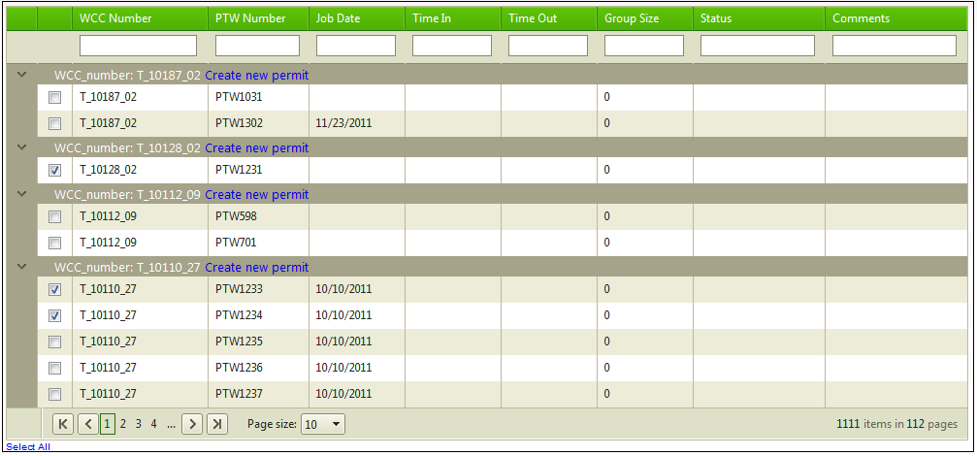

Screen Capture 45: print multiple permits

## Duplicating a Permit

You may want to use this option when you need multiple permits for the same job. With the permit you wish to duplicate selected, click **Duplicate This PTW** from the *Permit Menu*. The new permit will be a replica of the original, with the next available permit number. After duplication, you can go into the newly created permit to change the *Date/Time* field as needed.

## Adding a WCC to a Permit

Use this option when you wish to use the same permit for multiple WCCs. In order to attach a WCC to an existing permit, the WCCs have to be in the same unit, be in the same department and the work must be performed by the same company. Low-risk tasks can only be matched with other low risk tasks. Medium and high risk tasks can go together. Finally, the WCC status for the WCC you are attaching must be one of ‘Approved’, ‘Processed’, or ‘Exported to MTS’. If any of these conditions is not met, the WCC will not show up on the list for attachment.

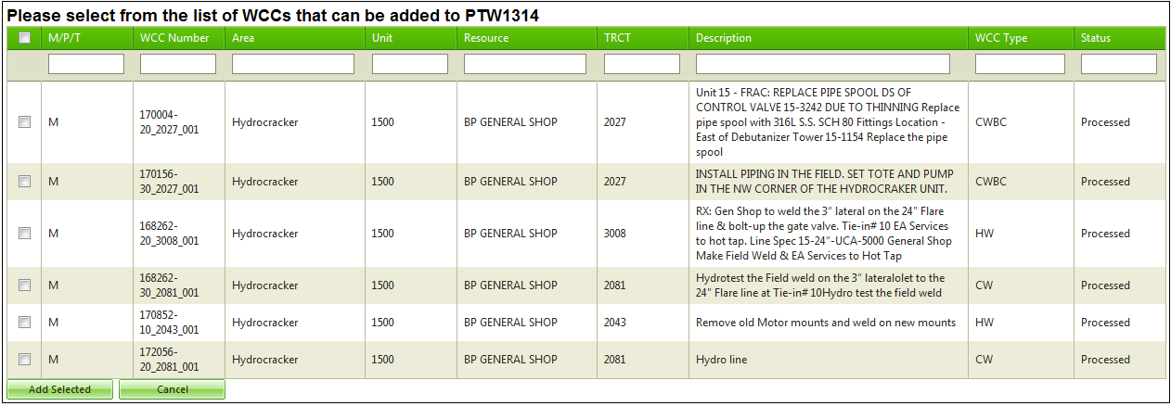

Screen Capture 46: adding a wcc to a permit

## Deleting Permits

**NOTE**: Deleting a permit is permanent!

To delete a permit, first access the list of permits either through the **Lookup Permit** option from the *Main Menu*, or through the **View Permits** option on the *WCC Menu*. Check the boxes in the leftmost column for each permit you wish to delete. From the *Permit Menu*, click **Delete Selected PTWs**. A confirmation dialog will ask you to confirm the deletion.



Screen Capture 47: permit deletion

# My Profile Menu

The *My Profile* *Menu* enables you to change your contact information, edit your user preferences, and change your password.

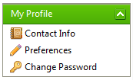

Screen Capture 48: my profile menu

## Contact Info

From the *My Profile* *Menu*, click **Contact Info**. From here you can change your name, email address and company. Click **Save** to save the changes, or **Close** to exit without saving any changes.

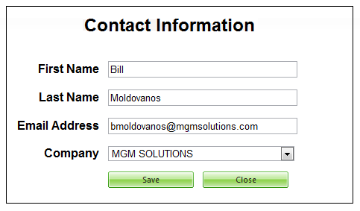

Screen Capture 49: contact information

## Preferences

There are five sections on the Preferences screen: Preferences, Automatic Filters, Backlog Settings, Backfill Settings, and Email Settings. Once you have made adjustments, click **Save** to save your settings. These settings are based on your NTID and will be in effect on any computer you log in on.

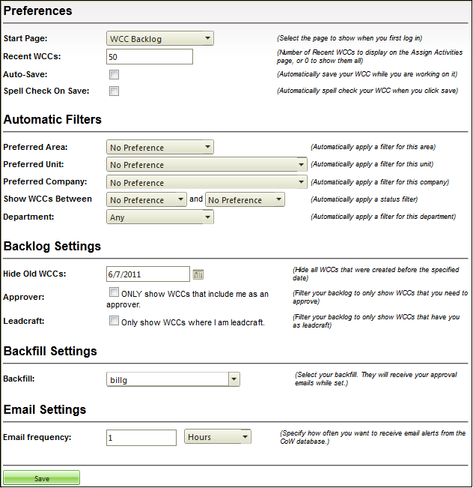

Screen Capture 50: my profile - preferences

### Preferences

Within the Preferences section, there are four options for you to customize. They are detailed below.

Start Page:

To change the start page that shows when you first log into the CoW Database, use the drop-down list. Choose from *Backlog*, *Manage JTPC*, and *Assign Activities*.

Recent WCCs:

Enter a number in the Recent WCCs field to determine how many recent WCCs to display on the *Assign Activity to WCC* page. Enter ‘0’ to display all WCCs.

Auto-Save

Check the Auto-Save box to have your WCC automatically saved as you work on it. The WCC will be saved after 5 seconds of inactivity (not entering or editing data in a field). Mouse movement does not constitute activity.

Spell Check on Save

Checking the ‘Spell Check on Save’ box will cause the spell checking feature to check your WCC for spelling errors whenever you click on the **Save WCC** button.

### Automatic Filters

The automatic filters settings apply to the four special data grids in the CoW Database (*Assign Activity to WCC*, *Assign WCC to JTPC*, *WCC Backlog*, and *JTPC Backlog*).

Use the drop-down list to select the *Preferred Area*, *Preferred Unit*, and *Preferred Company*. Selecting ‘No Preference’ from the drop-down list will remove any filters.

The *Show WCCS Between* filter enables you to show only WCCs with a certain status or between a range of two statuses. For example, setting the filter to ‘Created’ and ‘Ready for AA’ will show all WCCs that have the status *Created*, *Planning*, or *Ready for AA*. To show only WCCs with the status of ‘Planning’, set the filter to between *Planning* and *Planning*.

To filter by *Department*, select the department from the drop-down list. Select *Any* to show all three departments.

**NOTE**: if the Automatic Filters preferences conflict with the saved grid layout settings, the saved grid layout settings will take precedence.

### Backlog Settings

To hide all older WCCs, specify a cut-off date in the ‘Hide Old WCCs’ field. WCCs created on or after the date specified will show; older WCCs will no longer show.

Check ‘Only show WCCs that include me as an approver’ to filter out all WCCs in which you are not an approver.

Check ‘Only show WCCs where I am leadcraft’ to only show WCCs for work orders that you’ve created in Maximo.

### Backfill Settings

Use this filter to set your backfill. This setting will send Approval notifications to you (as usual) as well as the backfill person, and also allow them to approve WCCs where you are listed as the approver. When the backfill person approves WCCs on your behalf, it is their name that will appear in the signature field.

### Email Settings

You are able to set the frequency of email alerts you receive from the CoW database. Alerts can be sent as frequently as every 5 minutes. The time frame can be specified in minutes, hours, or days.

## Change Password

To change your user password, click **Change Password** from the *My Profile* *Menu*. Enter the new password of your choosing in the *Password* field, and then re-type the same password in the *Confirm Password* field to verify it. Click **Save** to save the changes, or **Close** to exit without saving the changes.

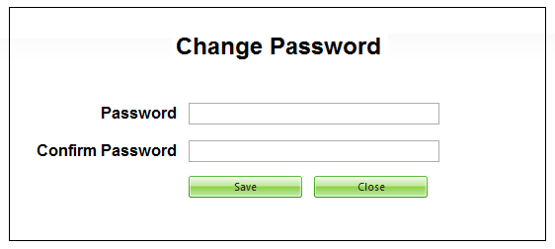

Screen Capture 51: my profile - change password

# Working with Data Grids

Data grids are used throughout the CoW Database to display data. They can be sorted by any column of your choosing, and filtered to narrow down the results that are displayed. Some of the data grids are special in that they are highly customizable. We cover these in the *Special Data Grids* section below.

## Sorting Data using the Data Grids

Sorting data using the data grids is easy. Simply find the column you wish to sort by, and click once to sort in ascending order. Clicking a second time will sort by descending order. Finally, clicking a third time will return the data to its default column sorting order. This will vary depending on the grid in question.

## Filtering Data Grid Results

Filtering results can help narrow down the results displayed. Underneath each column header is a text field or drop-down list. Type data into the text field or select from the drop-down lists to refine what appears on your list.



Screen Capture 52: column headers - filter data

## Navigating Multiple Pages

When there is a lot of data to display, there may be multiple pages to view. You can choose to view 10, 20 or 50 records per page, and can use the navigation bar to move through the pages. Use the left and right arrows to move to the previous or next page. The  button will move you to the first page of results, and the  button will move you to the last page of results.



Screen Capture 53: navigation bar

## Special Data Grids

There are four data grid displays within the CoW Database that have additional features. They are: Assign Activity to WCC data grid display, Assign WCC to JTPC data grid display, WCC Backlog data grid display, and JTPC backlog data grid display. Each of these special columns behaves in the same way.

### Re-Ordering Columns

To re-order the columns, left-click the header for the column you wish to move, and while holding the left mouse button down, drag the header to the location of your choice. Green arrows on your screen will indicate where it will be moved to. Once it is in the desired location, release the mouse button to drop it in place.

### Displaying or Hiding Columns

To change which columns are displayed, right-click on any header in the data grid, and choose *Columns* from the menu options. Check the header titles to include them, or un-check the header titles to exclude them.

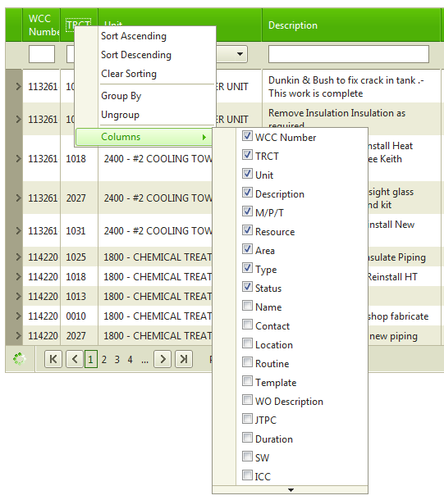

Screen Capture 54: Data Grids - show/hide columns

### Changing Column Widths

To change the width of a column, click the line between the column header you wish to re-size and the column header directly to its right. A white, double-sided arrow will appear on the screen, indicating that you are about to resize the column. Left-click and hold your mouse button and drag the arrow left or right to reach the desired width, and then release the mouse button.



Screen Capture 55: Data Grid - resize columns

### Grouping by Columns

The data displayed in within the four special data grids can be grouped by a column of your choosing. Right-click on the column you want to group by and click *Group By*. To remove the grouping, right-click on the column and click *Ungroup*.

### Quick Sort Options

As well as being able to click data grid headers to sort in ascending or descending order, the special data grids can also be sorted by right-clicking on any header in the data grid, and choosing one of: *Sort Ascending*, *Sort Descending*, or *Clear Sorting* from the resulting menu.

### Saving Your Special Data Grid Settings

Once you have your data grids set up according to your preferences, you can save the layout so that it will appear the same way every time you log into the CoW Database. Click **Save Grid Layout** to save the current layout. Once the grid layout has been saved, the same settings will appear on any computer that you log into with your NTID.

# Additional Functionality for Specific Roles

The table below lists each role that has additional features or functions available to them within the CoW Database.

|  |  |
| --- | --- |
| Role | Additional Functionality |
| AA | On WCC, can set *WCC Status* field to any status  On WCC, can change *WCC Type*  On WCC, can delete WCCs from *WCC Backlog* screen  On Ground Certificate & Electrical Certificate screens, can edit Approvers |
| CA | On WCC, can set WCC Status field up to but not including ‘Approved’  On WCC, can change *WCC Type*  On WCC, can delete an approver from the current WCC  On WCC, can remove an approval from the current WCC  On WCC, can edit all fields on routine WCCs  On WCC, can delete WCCs from *WCC Backlog* screen  On Ground Certificate & Electrical Certificate screens, can edit Approvers  On Ground Certificate & Electrical Certificate screens, can delete Approvers  On Ground Certificate & Electrical Certificate screens, can remove Approvals |
| OF | On WCC, can set *WCC Status* field to any status |
| PL | On WCC, can set WCC Status field up to but not including ‘Approved’  On WCC, can change *WCC Type*  On WCC, can delete WCCs from *WCC Backlog* screen  On JTPC Backlog screen, can delete JTPCs  On Quick Search results screen, can delete JTPCs, WCCs, and Activities  On Ground Certificate & Electrical Certificate screens, can edit Approvers |
| PS | On WCC, can set WCC Status field up to but not including ‘Approved’  On WCC, can change *WCC Type*  On WCC, can delete WCCs from *WCC Backlog* screen  On Ground Certificate & Electrical Certificate screens, can edit Approvers |
| RC | On WCC, can set WCC Status field up to but not including ‘Approved’  On WCC, can change *WCC Type*  On WCC, can delete WCCs from *WCC Backlog* screen  On Ground Certificate & Electrical Certificate screens, can edit Approvers |
| SC | On WCC, can change *WCC Type*  On WCC, can set WCC Status field up to but not including ‘Approved’  On WCC Backlog screen, can delete WCCs  On JTPC Backlog screen, can delete JTPCs  On Quick Search results screen, can delete JTPCs, WCCs, and Activities  On Ground Certificate & Electrical Certificate screens, can edit Approvers |
| SYSADMIN | On WCC, can set *WCC Status* field to any status  On WCC, can change *WCC Type*  On WCC, can delete an approver from the current WCC  On WCC, can remove an approval from the current WCC  On WCC, can edit all fields on routine WCCs  On Ground Certificate & Electrical Certificate screens, can edit Approvers  On WCC Backlog screen, can delete WCCs  On JTPC Backlog screen, can delete JTPCs  On Quick Search results screen, can delete JTPCs, WCCs, and Activities  On Lookup Permit results screen, can approve low-risk job permits (POWs)  On Ground Certificate & Electrical Certificate screens, can delete Approvers  On Ground Certificate & Electrical Certificate screens, can remove Approvals  On WCC, can modify WCC regardless of locked status. |
| TT | On Administrator Menu, can use Manage Templates to add/modify base TRCT templates. |

# Control of Work Authority and System Administrators

As a Control of Work Authority or System Administrator, you have an additional menu available to you - the *Administrator Menu*. From here you can manage templates, badges, users, companies, and imports, as well as set the TAR Mode for units and delete JTPCs.

Users with the role ‘TT’ (TRCT Template) have limited access to the *Administrator Menu* and are able to click the **Manage Templates** menu option to modify base TRCT templates.

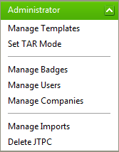

Screen Capture 56: administrator menu

## Managing Templates

From the **Manage Templates** option on the *Administrator Menu,* you can view, modify and enable or disable templates. Routine templates can be accessed and approved from here as needed.

### Working with Base TRCT Templates

To set up a base TRCT template for use in Control of Work, first create a step in Maximo with the work order number of 1005 (for Maintenance) or 1006 (for TAR). Once it has been imported into Control of Work, the template can be located by clicking the **Manage Template** option on the *Administrator Menu*, and then choosing the ‘Base TRCT Templates’ radio button.

Once the template has been opened, it can be modified as desired. Note that information in the tan highlighted area is specific to the template itself and will *not* be copied to WCCs that are based on the template.

Before a template may be used, it must be approved and then enabled. To enable or disable a template, click the enable/disable toggle located on the data grid list of available TRCT templates. Disabling a template does not remove approvals.

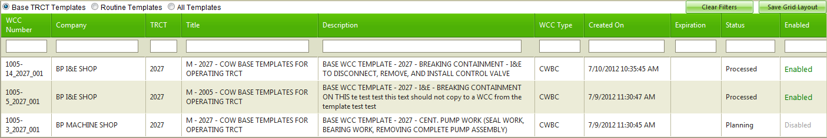

Screen Capture 57: administrator - manage templates - base trct templates

### Re-Approving Routine Templates

To re-approve a routine template, click **Manage Templates** on the *Administrator Menu*, and then choose the ‘Routine Templates’ radio button option.

## Managing TRCTs

To add or modify a TRCT, click **Manage TRCTs** from the *Administrator Menu*.

From the resulting screen, select a TRCT from the data grid by clicking the pencil icon (), or click **Add TRCT** to add a new TRCT. TRCTs are also enabled or disabled here. Click the word ‘Enabled’ or ‘Disabled’ to toggle the setting. Only enabled TRCTs will be used by the Control of Work application.

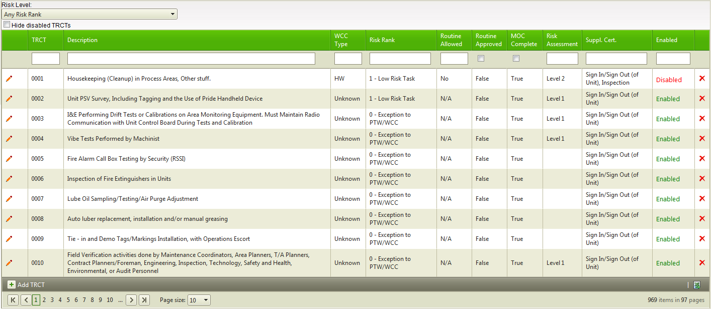

Screen Capture 58: manage trcts data grid

All fields for each TRCT can be modified except for the TRCT number. The ‘*Comments*’ field at the bottom right of the screen can be used to note reasons for modifying the TRCT. It does not appear on the WCC.

Required approvers added to the list here will automatically be added to any new WCCs that are based on the TRCT, assuming that the TRCT is enabled. When a user changes the TRCT on a WCC, all files associated with the current TRCT will be removed and replaced with files from the new TRCT. Files that were added independently will not be affected.

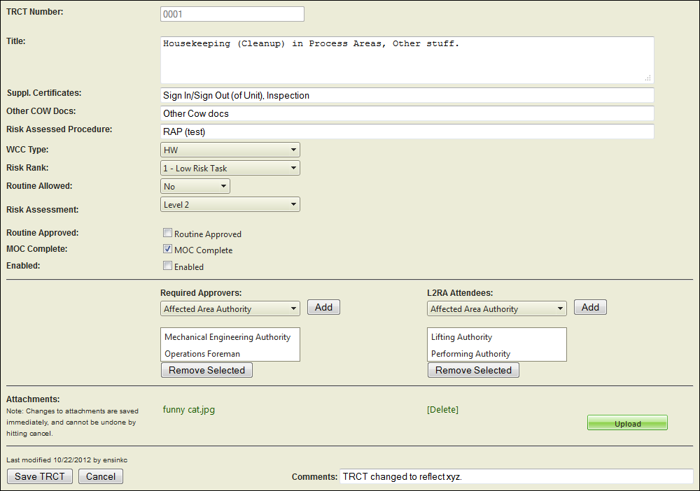

Screen Capture 59: add/modify a trct screen

Once the TRCT has been enabled, any newly created WCC with a matching TRCT will contain the updated TRCT information. The changes made to a TRCT are not automatically reflected in WCCs that are beyond the ‘*Created*’ status.

## Setting TAR Mode

To put a unit in TAR Mode, select Set TAR Mode from the Administrator Menu. The drop-down list can be used filter to the list by area. Click ‘ON’ or ‘OFF’ to toggle between modes.

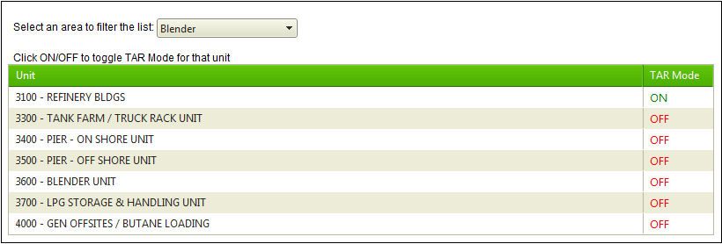

Screen Capture 60: administrator - set tar mode

## Managing Badges

Badges are used in the Maintenance Tracking System (MTS). As a System Administrator or CoW Authority, you are able to view, add, and edit badges. To begin working with badges, go to the *Administrator Menu*, and click **Manage Badges**.

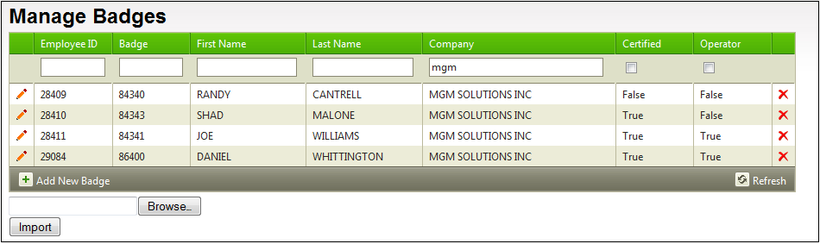

Screen Capture 61: administrator - manage badges

### Adding a New Badge

To add a new badge, click **Add New Badge** from the *Manage Badges* screen. Fill in the *Employee* *ID*, *Badge*, *First Name*, *Last Name*, and *Company* Fields. If the user is Performing Authority Certified (can have permits issued to them), check the ‘PA Certified’ check box. If the user is an Operator (has authority to issue permits), check the ‘Operator’ check box. Click **Save User** to save the new badge, or click **Cancel** to go back to the *Manage Badges* screen without adding the new badge.

### Editing an Existing Badge

To edit the information for an existing badge, find the badge from the data grid on the *Manage Badges* screen and click the *Edit* icon (). Once the changes have been made, click **Save User** to save the changes, or click **Cancel** to go back to the *Manage Badges* screen without saving the changes.

### Importing the Current Badge File

The current badge file is uploaded by MGM Solutions at this time.

## Managing Users

On the *Administrator Menu*, click **Users** to manage the user settings. From this screen, you can view user settings, edit user settings, and add new users. Use the data grid filters to narrow down the search results as needed. For more information on working with data grids, see Section 10 Working with Data Grids on page 44 of this user’s manual.

### Editing User Information

To edit a user’s settings, click the *Edit* icon () to the left of the user’s NTID. From this screen, you are also able to reset the user’s password. Clicking **Reset Password** will reset the user’s password to ‘password’. To save changes made to the user’s information, click **Save User**. To exit without saving the changes, click **Cancel**.

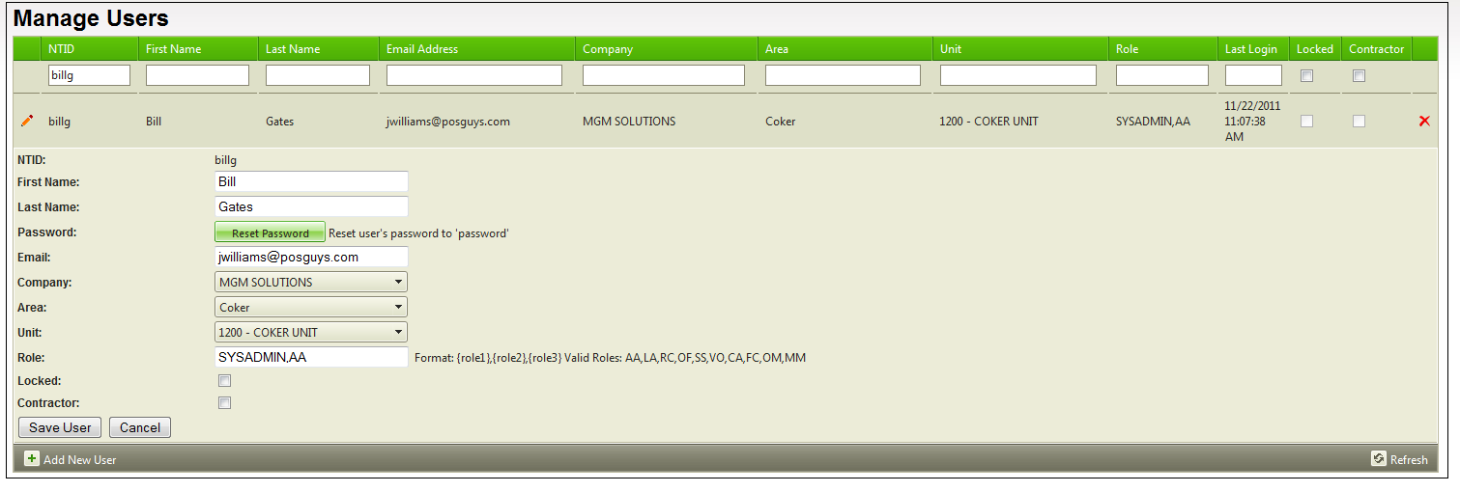

Screen Capture 62: administrator - edit user info

### Adding a New User

To add a new user to the CoW Database, click **Add New User** on the *Manage Users* screen. After filling out their information, click **Save User** to add them to the system, or click **Cancel** to exit without adding them.

## Managing Companies

The **Manage Companies** screen enables you to add or edit company information.

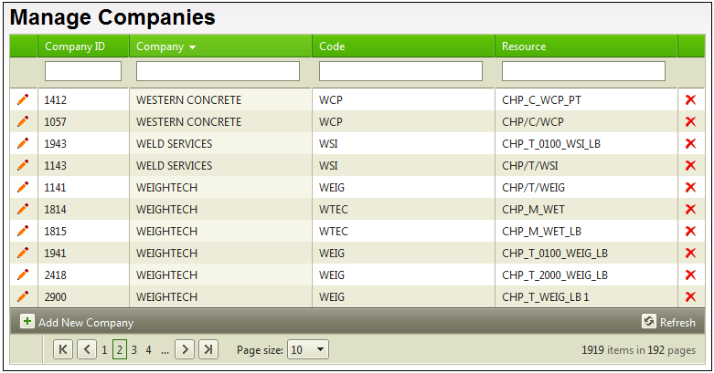

Screen Capture 63: administrator - manage companies

### Editing Company Information

To edit a company’s information, click the *Edit* icon () to the left of the *Company ID*. Edit the information as needed. To save changes made to the company’s information, click **Save Company**. To exit without saving the changes, click **Cancel**.

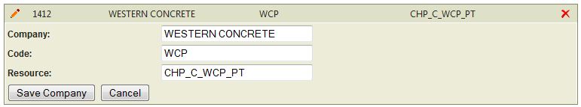

Screen Capture 64: manage companies - edit company information

### Adding a New Company

To add a new company to the CoW Database, click **Add New Company** on the *Manage Companies* screen. After filling out the information, click **Save Company** to add them to the system, or click **Cancel** to exit without adding them.

## Managing Import Files

The Manage Import Files screen can be used to view the status of files, view file contents, re-import files, delete files, and archive files.

To manage import files, click **Manage Imports** on the Administrator menu.

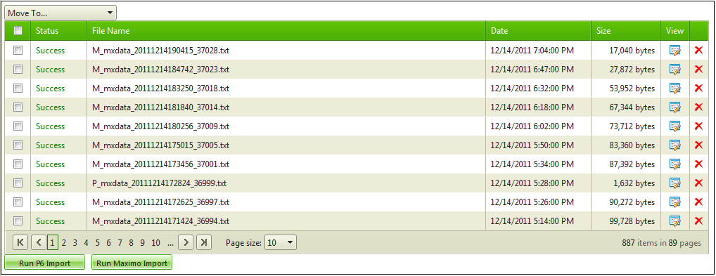

Screen Capture 65: administrator - manage imports

### Viewing the Status of a File

There are 5 potential statuses for a file: Pending, Importing, Success, Error, and Archive. The Status column in the data grid indicates the status of each file in the list.

Pending Status: The Pending status indicates that the file is available for import, and will be imported when the system next imports a batch of files. This occurs every 5 minutes.

Importing Status: The ‘Importing’ status indicates that the file is currently being imported into the system.

Success: A file with this status has been successfully imported into the CoW Database without any errors.

Error: A file with this status was imported into the CoW Database, but with errors. Importing this file again may fix the errors.

Archive: A file with this status has been imported successfully. Files are set to this status to in order to speed up the search process for more current files.

### Viewing the Contents of a File

To view the contents of a file, locate the file in the list, and click the ‘View’ () icon.

If you are looking for a file containing a particular Work Order Number, AMR Number, or Job ID, you can enter the applicable number in the ‘*Search for text*’ field and click **Search**. Wait a few moments for the list to refresh. It will show all files containing your search criteria, with the most recent import file listed first.

Note: You are not able to search for WCC or JTPC numbers as they do not exist in the import files.

### Re-Importing Files into CoW

To re-import files into the CoW Database, check the box for each file you want to re-import. Use the ‘Move To…’ drop-down list to select ‘Pending.’ The next time an import occurs in the system, the files will be imported again.

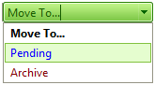

Screen Capture 66: manage imports - move files to pending

### Deleting Import Files

To delete an import file, select it from the list and click the ‘Delete’ () icon. Deleting an import file will not delete information already imported into the CoW Database.

### Archiving Files

Older import files can be archived periodically. This makes the Search feature work more quickly as it has fewer files to search through.

If you wish to, click the Date column to reorder the import files by date, with the least recent first. Check the boxes for all files you wish to archive, then use the ‘Move To…’ drop-down list to select ‘Archive.’ A dialog box will ask you to confirm the process.

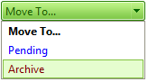

Screen Capture 67: manage imports - move files to archive

## Deleting JTPCs

This special section of the *Administrator Menu* is for deleting an entire JTPC and ALL WCCs, Activities, Permits and Supplemental Certificates associated with that JTPC. From the *Administrator Menu*, click **Delete JTPC** to find and select a JTPC for deletion. Enter the JTPC number, and then click **Find JTPC**. To delete the JTPC, select it from the list and click **Delete JTPC**. A dialog box will open up asking you to confirm the deletion.

**NOTE**: Deletion is permanent.